Pillage the Village Development Log: Michael

Team MDJS |

TotaL: 43hours across 4 weeks.

Michael Jordan (14868336)

2017

# Sunday 8th October [6:20pm - 7:03pm]

* Added the iniparser code from my individual project to the group project.
* Created the .h file for Map with a reference to a non existant Tile/Tower class.
* Created the .h and .cpp for Tile class.
* Created the .cpp file for Map class.

# Wednesday 11th October [12:25pm - 1:52pm]

* Created the .h and .cpp files for the MapFactory
* Main altered to allow map testing.
* Started on track generation

# Thursday 12th October [10:03am - 12pm]

* Implemented the main recursive function to find the track, but encountered a bug.
* [Bug 001: Map class]
  + The GetTile(int x, int y) is returning two different addresses of a tile, although it is given the same parameters.

# Friday 13th October [8am - 9:41am]

* [Bug 001: Map class]
  + Solved! The tile array wasn't initialised properly. It needed to be an array of Tile pointers (rather than just tiles).
* Started Testing the track generation with the condition that it must succeed 5 times. "Track Generation Testing cases.pdf"
* [Testing: Track Recursion]
  + [version 1.0]
    - First generation of code.
    - Loops on itself, but can reach the goal?
    - Not enough conditions and the current condition might be preventing movement after a "RIGHT" movement.
  + [version 1.1]
    - Added a condition to not visit tiles that have an established center point.
    - Does not reach the goal, because the previous conditions were removed.
  + [version 1.2]
    - Cleaned code and removed non-relevant comments
  + [version 1.3]
    - Previous condition added alongside the newly added conditions (v1.1).
    - It was discovered that the randomiser can't make y = 2.
  + [version 1.4]
    - All working and passed 5 times.

* Comment: I feel like the code could be refactored to be smaller/cleaner.
* Test visually displayed:

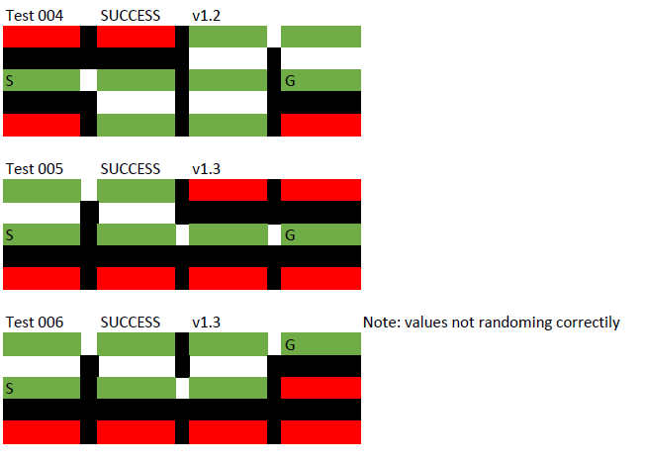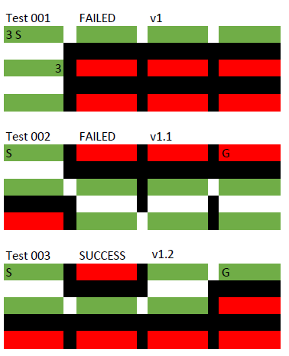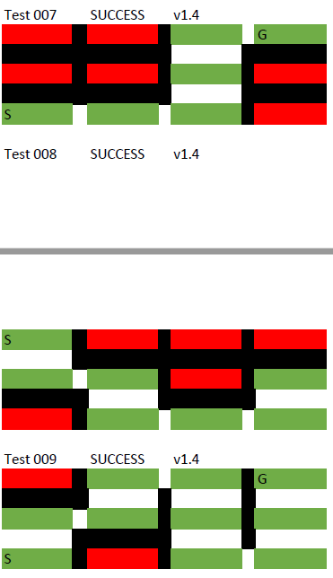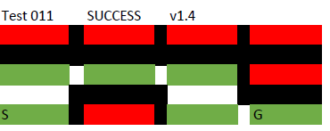

# Friday 13th October [10:30am - 10:50am]

* Created the clear temporary tile (from editing Jack's files)
* Moved temporary tile files to the assets folder.
* Created a tiles.ini file.
* Added access to the map classes from the game class. (To pass through the backbuffer)

# Monday 16th October [7:30am - 10:14am]

* Altered the tile.ini file to take in the additional tiles created by Jack.
* Allowed tiles to be drafted sprites within a .ini file.
* [Bug 002 - BackBuffer?]
  + Rotated tiles aren't lining up 100% correctly.
  + Causing a black line and jagged tracks being displayed.
  + Thought: Either the sprites aren't exactly rotatable or there is a pivot issue with the backbuffer.
* [Temp Fix]
  + If the sprite is rotated, then the x & y coordinates are misused 1.
* Added functionality to request nextTarget for a moving troop.
* Added comment suggestions to Dominic's code for alterations which would suit the map's code (e.g. setting targeting).

# Monday 16th October [11:30am - 2:15pm]

* Helped with cleaning code and searched for memory leaks (26 in total).
* [Leaks:] Allowing the texture manager to delete all loaded textures (9 Memory leaks).
* [Leaks:] Allowed the current testing data to be deleted (3 Memory leaks).
* Added functionality to the map class, to give and create tower coords.
* [Bug 004: Map class]
  + In the rare chance that the randomiser selects the minimum or maximum values (at each random).
  + Causing towers to share the same coord point.

# Wednesday 18th October [9:40am to 11:40am]

* I've taken up the task of using everybody’s code, to make a presentable version for the Alpha presentation.
* [Notes: ] To bring to the group about alterations:
  + Projectile class should initialise with a target, not the towers position.
  + TowerFactory doesn't need a backbuffer if a sprite is already being passed through
  + NormalTroop shouldn't have a process method. Only the states methods: {Move(), Act() and Halt()}
  + The state methods in NormalTroop should be virtual.
* [Bug 005: Unknown class (either troop, game or map)]
  + The troop isn't quite sticking to the track.

# Wednesday 18th October [4:00pm – 6:30pm]

* [Bug 005]
* [Fixed]
  + Refactored code to implement the m_usedTile vector;

# Friday 20th October [9:15am – 11:30am]

* [Bug 004]
* [Fixed]
  + Towers no longer generate on the 1st or last tile.
  + Towers no longer generate on the same tile.
* Screen Interface created and game class is using it.

# Thursday 26th October [10:36am - 1:42pm]

* imported autScreen.h from my individual assignment.
* moved the creation of the backBuffer to the main.
* changed the Initialise () method to accept a backBuffer parameter.
* Started to use Unique pointers to navigate the interface easier.
* Map now loads a different section of the tile.ini to use different styles of tiles.
* Tiles now scale on different screen sizes.
* New debug option, to recreate the map & towers. [Binded to 'P' button]

# Saturday 28th October [6:30am - 7:23pm]

* Map now generates flairs to the map
* Map now draws the flairs.

# Saturday 28th October [12:00am - 1:12am (29th)]

* Map now is correctly scaling upon the resolution changing.
* [10:30am - 4:47am (1/11)] (31/10 – 1/11) 18h

# Tuesday 31th October [10:30am - 4:47am (1/11)]

* Implemented the mask.h and Button.h into the new Screens.
* Created the pButton.png and line.png to be used within map select.
* MapScreen now pushes through a map towards game class.
* Made a line.png rotate and connect two buttons.
* Added IsEnabled to the button class and made it draw darker if it was disabled.
* Map now holds the id of the button clicked.
* Button vector converted to a vector of node structs.
* Fixed the Explosion problem for Shakeel
* Re updated my changes to game.cpp
* Created the background splash art for the main menu
* Fixed a crash that Shakeel was having with the village.
* loaded art assets to main menu.

# Wednesday 31th October [8:06AM - 9:20AM]

* Cleaned up some memory leaks created by game.cpp
* Fully implemented menuScreen